The Mission:

1. Data Dive (10 pts):

* Pick your dataset and click to download ([Social Media Users](https://drive.google.com/file/d/1_pw30q72z-09Arcu4dfnS4CUCUsNUx-G/view), [Netflix Shows](https://drive.google.com/file/d/1Cth8F5M7smd4uqE7QNX6vHBSOdK_eank/view?usp=sharing), or [Human Stampedes](https://drive.google.com/file/d/1_pw30q72z-09Arcu4dfnS4CUCUsNUx-G/view)).

I have chosen, Human Stampedes which is actually, Average Time Spent By A User On Social Media.

* Import it into MySQL Workbench ([learn how!](https://youtu.be/sfRwJH04QJc?si=yqYx0Hn78HJYuWd_)).

Done and altered the table on MySQL Workbench to social_media_stats.

* Briefly explain any difficulties and 1 interesting thing you noticed about your chosen dataset.

While there was no problem importing the .csv file into a new table, the table name was too long and was prone to being misspelled when creating queries.

2. Data Fun (20 pts):

* Use simple SQL queries to play with the data.

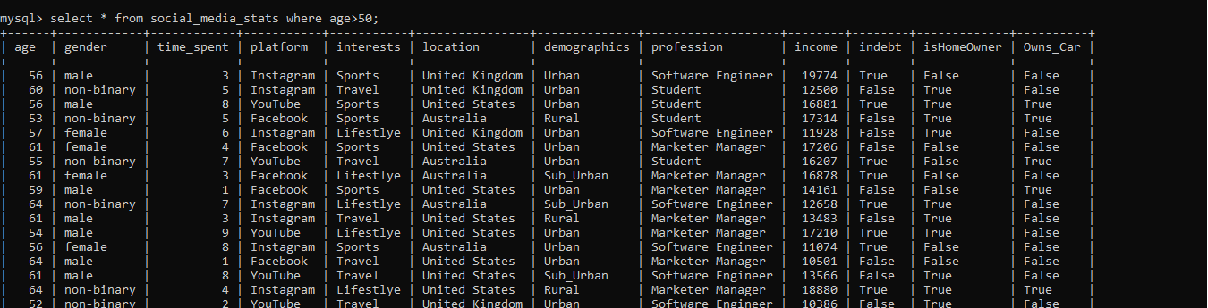

A quick query to see how many users over the age of 50 use social media sites displays that almost a third use social media (289 records).

SELECT COUNT(*) AS TotalUsers FROM social_media_stats;

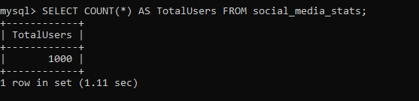

SELECT AVG(time_spent) AS AverageTimeSpent FROM social_media_stats;

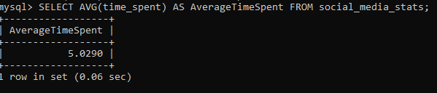

SELECT Gender, COUNT(*) AS UserCount FROM social_media_stats GROUP BY Gender;

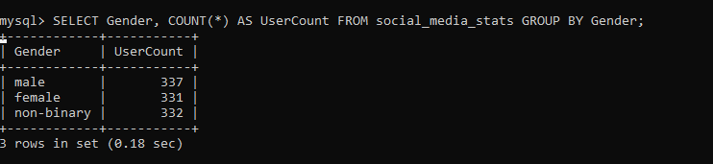

SELECT Platform, COUNT(*) AS UserCount FROM social_media_stats GROUP BY Platform;

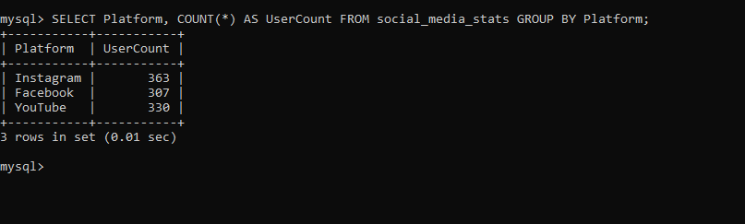

* Find 2 cool facts hidden within the data (e.g., most popular interests).

**Find Users Who Are in Debt and Own a Car**

SELECT * FROM social_media_stats WHERE InDebt = TRUE AND Owns_Car = TRUE;

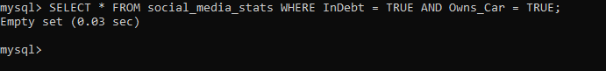

Nobody is in debt and owns a car Apparently!. Interesting.

SELECT Profession, COUNT(*) AS UserCount FROM social_media_stats GROUP BY Profession;

Apparently our career has the most social media users. Interesting.

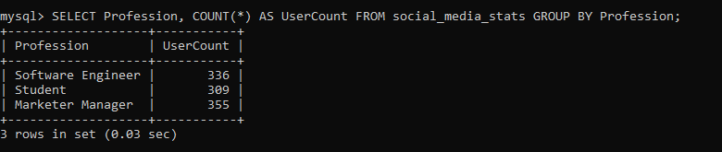

* Use basic SQL queries like (COUNT, AVG, and SUM) to understand more about the data you have.

### **Find the Maximum, Minimum, and Average Income**

SELECT

MAX(Income) AS MaxIncome,

MIN(Income) AS MinIncome,

AVG(Income) AS AverageIncome

FROM social_media_stats;

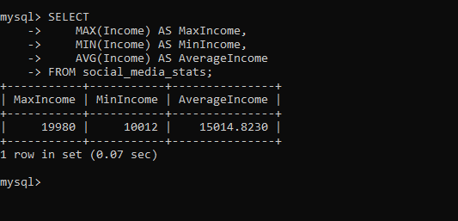

**Get the Number of Users by Location**

SELECT Location, COUNT(*) AS UserCount FROM social_media_stats GROUP BY Location;



SELECT * FROM social_media_stats WHERE time_spent > 5;

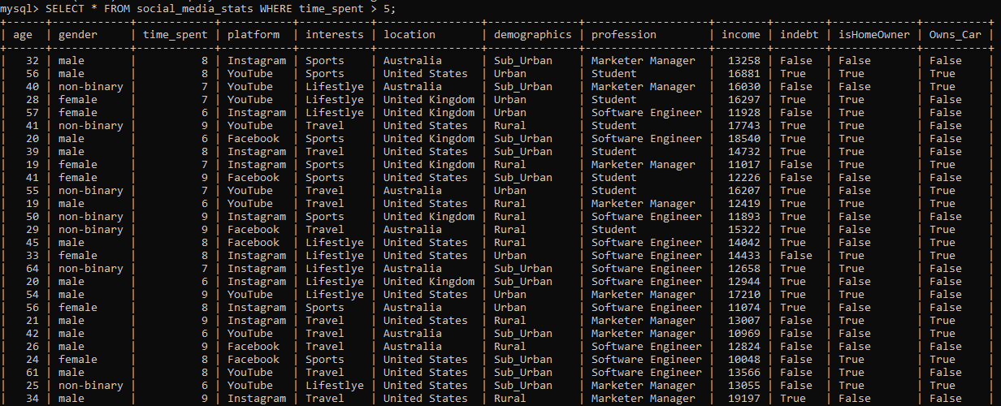

437 rows

### **List Users by Category and Sort by Time Spent**

SELECT * FROM social_media_stats WHERE Interests = 'Sports' ORDER BY time_spent DESC;

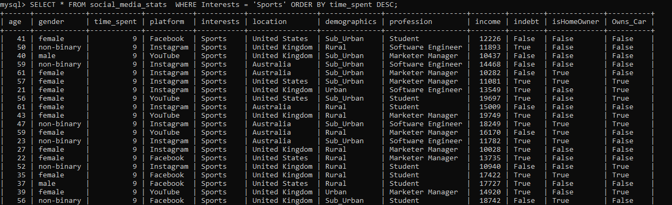

**List All Unique Interests**

SELECT DISTINCT Interests FROM social_media_stats;

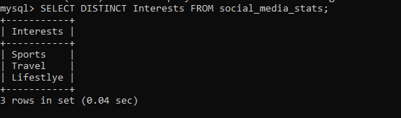

**Find the Average Time Spent on Social Media**

SELECT AVG(time_spent) AS AverageTimeSpent FROM social_media_stats;

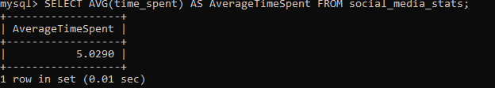

**Find the Total Time Spent on Social Media by All Users**

SELECT SUM(time_spent) AS TotalTimeSpent FROM social_media_stats;

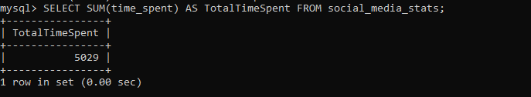

**Count the Number of Users by Gender**

SELECT Gender, COUNT(*) AS UserCount FROM social_media_stats GROUP BY Gender;

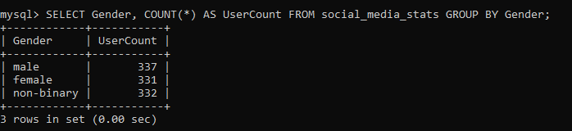

**Find the Average Income of Users**

SELECT AVG(Income) AS AverageIncome FROM social_media_stats;

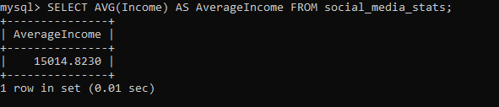

**Count the Number of Users Who Are in Debt**

SELECT COUNT(*) AS InDebtCount FROM social_media_stats WHERE InDebt = TRUE;

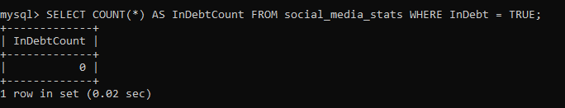

**Calculate the Total Income of Users Who Are in Debt**

SELECT SUM(Income) AS TotalIncomeInDebt FROM social_media_stats WHERE InDebt = TRUE;

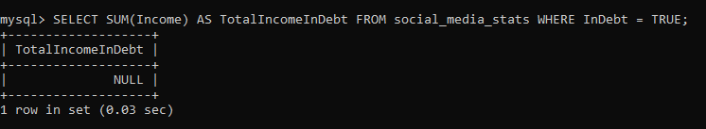

**Count the Number of Users by Profession**

SELECT Profession, COUNT(*) AS UserCount FROM social_media_stats GROUP BY Profession;

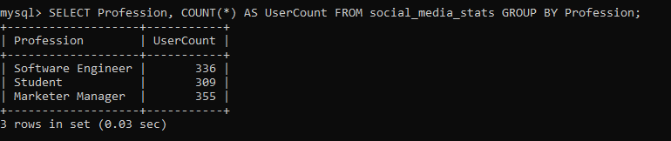

**Find the Average Time Spent on Social Media by Gender**

SELECT Gender, AVG(time_spent) AS AverageTimeSpent FROM social_media_stats GROUP BY Gender;

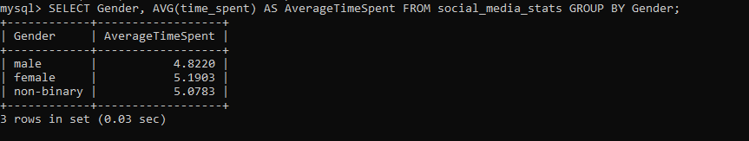

3. Ask Away (30 pts):

* Formulate 2 questions about the data (e.g., what are popular shows in different countries?).

**1.Query to Count Users by Platform for a Specific Age Group:**

Count Users by Platform for the Age Range 18-24:

SELECT

Platform,

COUNT(*) AS UserCount

FROM

social_media_stats

WHERE

Age BETWEEN 18 AND 24 -- Specify the age range

GROUP BY

Platform

ORDER BY

UserCount DESC;

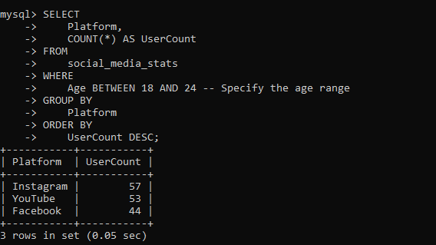

### **Question 2: What Is the Average Time Spent on Social Media by Users with Different Income Levels?**

This question seeks to analyze how income levels influence the time users spend on social media. It can provide insights into the relationship between users' financial status and their social media usage patterns.

* Write basic SQL queries (WHERE, ORDER BY) to find answers.

SELECT Platform, AVG(time_spent) AS AverageTimeSpent FROM social_media_stats GROUP BY Platform ORDER BY AverageTimeSpent DESC;

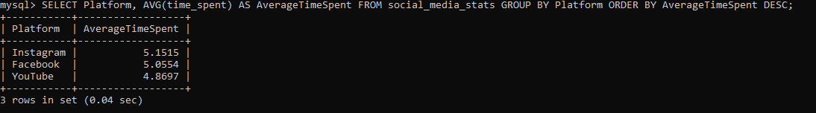

* Share what you learned from the answers.

**Question 1: Count Users by Platform for a Specific Age Group (18-24):**

This query helps us understand the popularity of different social media platforms among users aged 18 to 24. The result will show which platform has the highest number of users in this age group, indicating trends and preferences among younger users.

### **Question 2: What Is the Average Time Spent on Social Media by Users with Different Income Levels?**

Platforms with higher average time spent may indicate stronger user engagement. For instance, if Instagram has a higher average time spent than Facebook, it suggests that users find Instagram more engaging.

**How and where to apply the findings**

**Marketing Strategies:** Tailor marketing campaigns based on the popularity and engagement metrics of different platforms. For example, if a brand targets young adults, they might focus more on platforms like Instagram.

**Content Development:** Create content that aligns with user engagement trends. If users spend more time on certain platforms, developing more content for those platforms can be beneficial.

**Product Development:** For app developers, understanding user preferences and engagement can guide feature development and UX improvements to increase user retention.